**Hands-on Documentation: Mockito Exercise 2**

**Title:**

Mockito – Verifying Method Interactions with verify()

**Objective:**

To verify that a **mocked method** was called during a test using Mockito.verify().

**Tools Used:**

* Java 8+
* IntelliJ IDEA
* JUnit 5
* Mockito 5.12.0
* Maven

**Steps Performed:**

**Same Setup as Exercise 1:**

* Interface: ExternalApi with method getData()
* Class: MyService that calls getData() in fetchData()

**Test Code:**

@Test

public void testVerifyInteraction() {

ExternalApi mockApi = Mockito.mock(ExternalApi.class);

MyService service = new MyService(mockApi);

service.fetchData();

verify(mockApi).getData(); // Verifies interaction

}

**Output:** 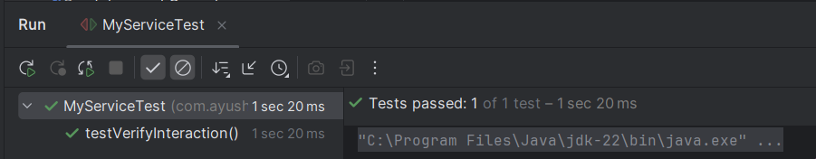

**Conclusion:**

* Practiced **Mockito behavior verification** using verify().
* Ensured proper interaction between service and dependency.
* Essential for **validating integration between classes** without real implementations.